**FOCUS GROUP DISCUSSION**

**Definition:** A Focus Group Discussion (FGD) is a qualitative research method and data collection technique in which a selected group of people discusses a given topic or issue in-depth, facilitated by a professional or external moderator.

**WHAT IS THE PURPOSE OF THE FOCUS GROUP?**

**Ask yourself these questions:**

1. What is the problem that the study is to address?
2. What is the purpose of the study?
3. What kinds of information do you want?
4. What types of information are most important?
5. Who wants the information? (Or, who do you want to give the information to?)
6. How will you use the information? (Or, what do you want others to do with the information?)
7. Are there any ethical, legal, economic, or social considerations that lead researchers to favor one research procedure over another?

**HOW DO YOU RECRUIT THE PARTICIPANTS?**

There are number of strategies used to select participants of focus group discussion as:

Use sampling procedures such as purposive sampling, snowball, random selection etc.

**DETERMINE WHAT TYPES OF PEOPLE CAN GIVE YOU THE INFORMATION YOU WANT.**

* What types of people have the greatest amount of insight on your study topic? Select participants who have in-depth knowledge and experience on your study topic.
* Focus group comprises of two to ten people.

**DETERMINE HOW MANY GROUPS TO CONDUCT**

* The accepted rule of thumb is to plan three or four focus groups with each type or category of participant.
* After you have conducted these first three or four groups, determine if you have reached saturation.
* Saturation is a term used to describe the point where you have heard the range of ideas and aren’t getting new information.

Note: Balancing the Design With the Resources Available. One of the challenges of focus group research is budget overrun.

**DEVELOP FOCUS GROUP GUIDE**

To guide the focus group discussion, develop a focus group interview guide with questions.

Focus Group Discussion/Interview guide structure is as follows:

**STRUCTURE - FOCUS GROUP DISCUSSION GUIDE**

**Section A: Opening question**

The first section focuses on an opening question which aimed at getting all participants to say something early on in the conversation.

**Example:**

Provide me your name and any other project you are involved with in maternal health care. (you need to refine the question as per your research topic)

Top of Form

**Section B: Introductory question**

The second section focused on an introductory question which aimed at introducing the topic of discussion and get participants to start thinking about their connection with the topic.

**Example**

What are the challenges facing maternal health care in Tanzania?

**Section C: Transition question**

Focus on the transition questions which aimed at moving the conversation into the key questions that drove the research study.

**Example**

Could you briefly tell me, what causes increase of maternal mortality rates in Tanzania?

**Section D: Key questions**

Focus on the key questions which aimed at driving the research study.

You have to include the key questions which are aligned with your research questions.

**Section E: Concluding questions**

Focus on the concluding questions which aimed at concluding the focus group discussion.

**Example:**

1. Do you think this Interactive Voice Response System can be used in your organisation?
2. What would be the benefits of using this Interactive Voice Response System in Maternal Health Care?

**Section F: Final question**

Focus on the final question which aimed at ensuring that critical aspects have not been overlooked during the focus group discussion.

**Example:**

Is there any important items that we missed in our discussion today?

**Table: Example of Focus Group Questions**

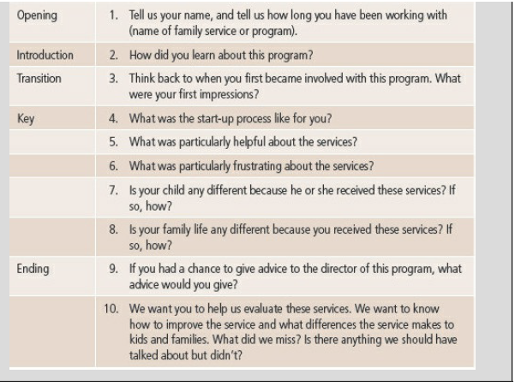

**HOW DO YOU CONDUCT THE FOCUS GROUP DISCUSSION?**

You have already prepared the guide for your focus group, how do you conduct the focus group?

1. Make sure you have Ethical Clearance Letter for your research.
2. List of the participants
3. Invitation letter
4. Time slots
5. Venue/ Focus Group event program
6. Facilitator/Moderator
7. How to record the conversation?
8. Transcribe

**HOW DO YOU ANALYSE DATA FROM THE FOCUS GROUP DISCUSSION?**

Which software tool will you use to analyse data?

Process: Data collection, Data coding, Data preparation, Data analysis, Interpretation of results.

**References**

Krueger, R. A. (1994). *Focus Groups: A Practical Guide for Applied Research*. Thousand Oaks, California: Sage.

Krueger, R. A & Casey, M.A. (2000). *Focus Groups: A Practical Guide for Applied Research*. (3rd ed.). Thousand Oaks, California: Sage.

Krueger, R. A. & Casey, M. A. (2009). *Focus groups: A Practical Guide for Applied Researchers*. (4th ed.). Thousand Oaks, California: Sage.

Krueger, R. A. & Casey, M. A. (2015). *Focus groups: A Practical Guide for Applied Researchers*. (5th ed.). Thousand Oaks, California: Sage.